DOI:

*Corresponding author

(a) , ORCID iD
(b) , ORCID iD
(c) ORCID iD

Abstract

The abstract should be presented as a single paragraph and briefly summarize the goals, methods, and new results presented in the manuscript. Reference citations are not allowed.

- Main Text

Times New Roman 10 pt. The paragraphs continue from here and are only separated by headings, subheadings, images and formulae. The section headings are arranged by numbers, bold and 10 pt. Spelling in APA Style papers should conform to the Merriam-Webster.com Dictionary (https://www.merriam-webster.com). The default font for this template is Times New Roman.

- Heading level 1
  - Heading level 2
    - Heading level 3
      - Heading level 4
  - Structure

Files must be in MS Word. Follow this order when typing manuscripts: Title, Authors, Affiliations, Abstract, Keywords, Main text (i.e. introduction, problem statement, research questions, purpose of the study, research methods*, findings*, conclusions*), Acknowledgements, References, Appendix.
*Headings marked with asterisks are required for the main text.
References must be listed at the end of the paper. Authors should ensure that every reference in the text appears in the list of references and vice versa.
  - Section headings

Section headings should be left justified, bold, with the first letter capitalized and numbered consecutively, starting with the Introduction. Sub-section headings should be in bold, with the first letter capitalized and numbered 1.1, 1.2, etc, and left justified, with second and subsequent lines indented.

    - Heading Level 3
      - Heading Level 4

- Tables & Figures
All figures and tables should be referred in the text and numbered in the order in which they are mentioned.
  - Tables

All tables should be numbered with Arabic numerals (1, 2, 3, ….). Every table should have a caption. Headings should be placed above tables, left justified. Only horizontal lines should be used within a table, to distinguish the column headings from the body of the table, and immediately above and below the table. Tables must be embedded into the text and not supplied separately. Below is an example which the authors may find useful.

- Type your title
Column Heading | Column Heading | Column Heading | Column Heading
Column text 1
Column text 2
Column text 3

  - Figures

All figures should be numbered with Arabic numerals (1, 2, 3, ….). Every figure should have a caption. Figures can be saved in .jpg, .gif, .tif or .eps format, at 150 dpi resolution. When preparing figures, please make sure that any characters or numbers included in the figures are large enough to read on-screen. Low-quality scans are not acceptable. Figures must be embedded into the text and not supplied separately.

- Type your title here

- Type your title here

- Copyright

Submission of a manuscript implies that it reports unpublished work, that it is not under consideration for publication elsewhere and that, if accepted, it will not be published elsewhere in the same form, either in English or in any other language, without the consent of the publisher. If previously published tables, illustrations or more than 200 words of text are to be included, then the copyright holder's written permission must be obtained. Include copies of any such permission letters with your paper. Please note that if considered appropriate, plagiarism checking software may be applied to your manuscript during the editorial review process.
Acknowledgments [if any]
Acknowledgements and Reference heading should be left justified, bold, with the first letter capitalized but have no numbers. Authors are responsible to list all funding sources in the Acknowledgments section. Please provide details of the sources of financial support for all authors, including grant numbers. For more information, please check the CrossRef’s Open Funder Registry.
References
References should be written according to APA 7 style. All references should be listed alphabetically, with the majority of current works. All references should be cited both in text and in the reference list (check pages 12-20 for further details and examples).

Zehir, C. & Özşahin, M. (2008). A field research on the relationship between strategic decision‐making speed and innovation performance in the case of Turkish large‐scale firms. Management Decision, Vol. 46 No. 5, pp. 709-724. https://doi.org/10.1108/00251740810873473

Zehir, C., Zehir, M., Borodin, A., Mamedov, Z. F. & Qurbanov, S. (2022). Tailored Blockchain Applications for the Natural Gas Industry: The Case Study of SOCAR. Energies, 15, no. 16: 6010. https://doi.org/10.3390/en15166010

Notes:

- The format of the main text of the manuscript is flexible: it should be concise and in the format most appropriate to displaying the content of the manuscript. However, each manuscript should have research methods, findings, conclusions sections.

- All EpSBS styles can be found in the styles panel of the template.

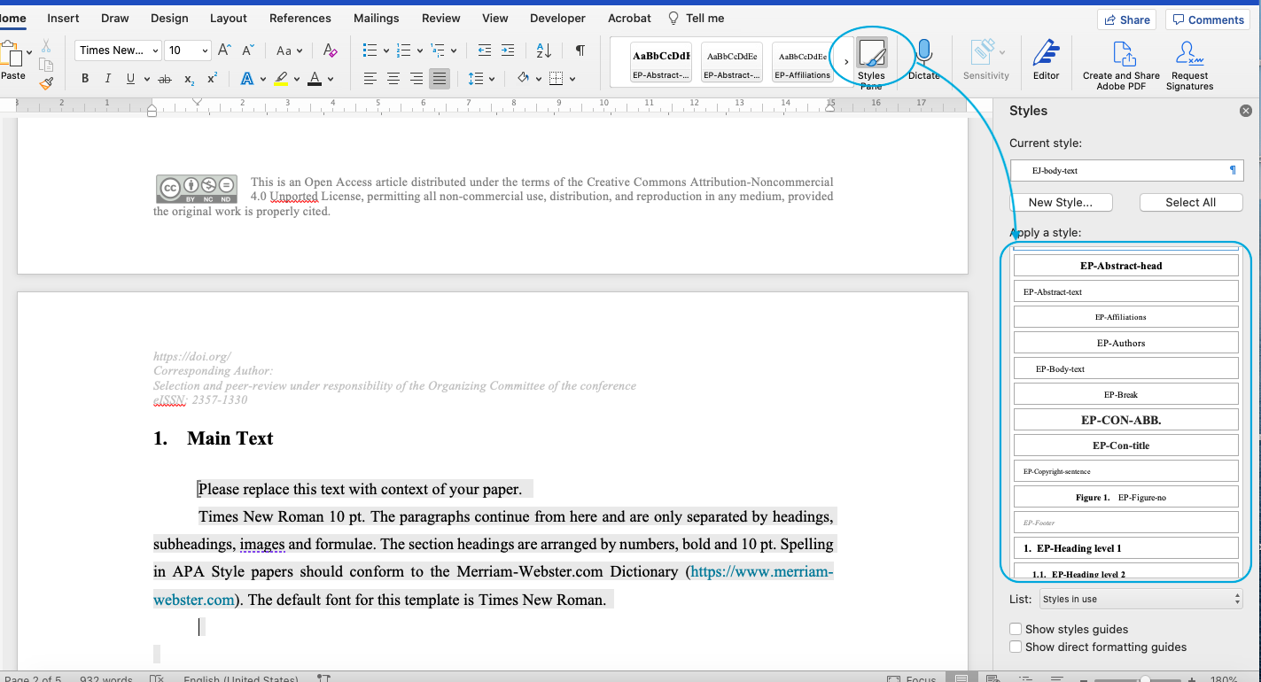

- Authors can easily create new headings by using the “Styles Panel” as shown in the screenshot below:

